NEWSLETTER
28th July 2021

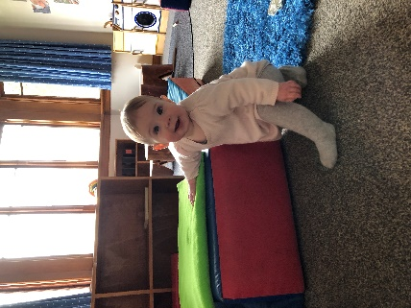
Nursery/Tui Room
Over the past month we have been focusing on Manaakitanga which involves caring attitudes and a willingness to support each member of the collective group. Kaiako have observed this in daily interactions between tamariki as they share the space and resources, exploring alongside each other. Tamariki have been taking responsibility as they grow their independence skills and participate in caring for themselves, each other and our environment.
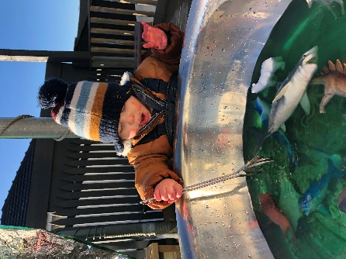
We have been engaging in messy play exploration, children have been exploring happily alongside each other in small groups. We have continued to offer imaginative play opportunities for tamariki to express their thoughts and feelings and share their previous knowledge/experiences of caring and supporting others. Kaiako continue to engage in and role model reciprocal hospitality and respectful interactions and notice tamariki incorporating this into their own interactions.

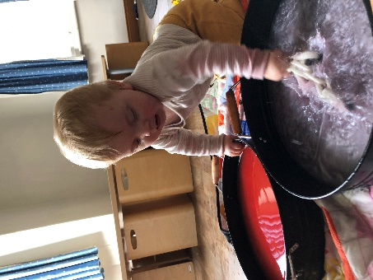

Preschool/Pukeko Room
For the past couple months our group focus was, Whanaungatanga, all about building relationships through shared experiences and working together. It has been wonderful to see the children all coming together during different aspects of our daily programme, supporting and nurturing relationships among the group.

The children had fun working together to make our very own Matariki soup, displaying great skill as they chopped and grated the different ingredients. The leftover food scraps were then spontaneously turned into the Matariki boats, what great creativity!

Our new whare, thanks to talented Jonathon, has provided a special, quiet space to read a book or a firm favourite place for hide-and-seek. Group games, like hide-and-seek, provide an opportunity for children to have fun together, while exploring turn taking and following set 'rules'.

Our group time before lunch is a wonderful opportunity for us all to come together and it has become an anticipated part of our routine for many. We have been exploring fast and slow and loud and soft using our rakau sticks and our bodies. This has required great listening skills, rhythm and sustained focus. The song "Count to 100 workout song" was introduced and has quickly become a request by both our young and old children, leading to lots of fun and laughter. Through yoga the older children explored slow, more structured movements that provided a sense of calm.

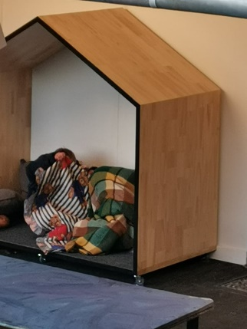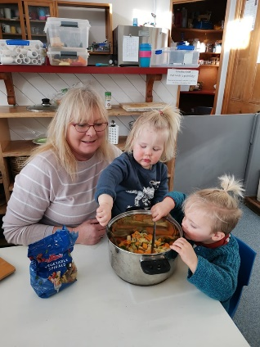

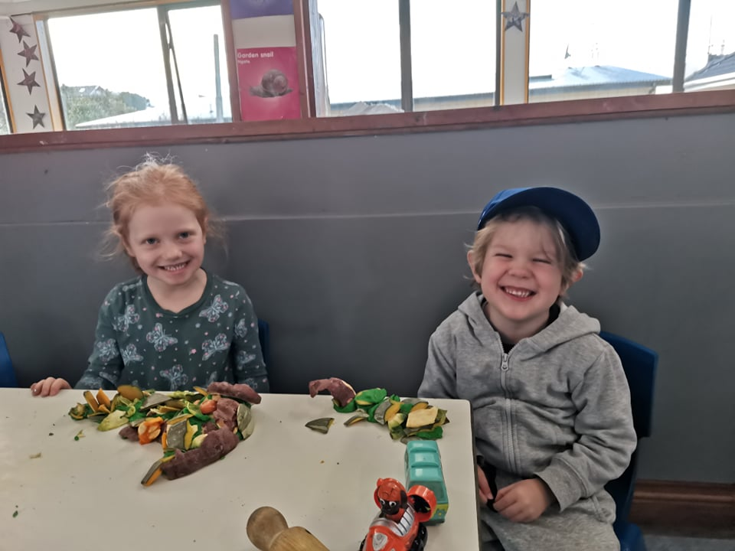

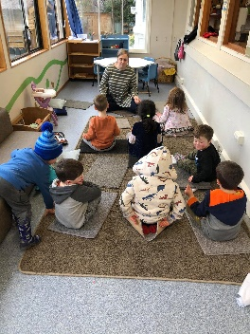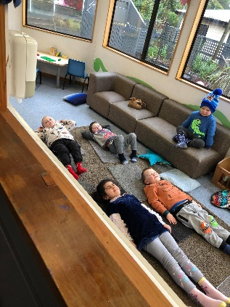

Staff news
We have said farewell to Georgia and wish her well on her new adventure. We are lucky to have Lizzy joining our team at the end of August. She is a qualified and very experienced teacher with a leadership background. She will be bringing her youngest daughter Indi with her.

Our tamariki
Happy school days to: Oliver.
Farewell to: Aseman. Best wishes to Harriet and Eleanor M on your move to Invercargill.

Welcome to our new children: Luca, Darren, Riley and Indi.

Notes
Our enrolments are now almost at capacity. We have do however have spaces on Fridays if you are looking to extend your bookings.

Please have your Scholastic book club orders in by 13th August. Last term we purchased a lot of new books and it was lovely to have Scholastic rewards to go towards purchasing these.

RSV
Thank you to our families for keeping your children home when unwell. There has been a lot of winter illnesses in the community including RSV which is a common respiratory virus.

RSV is highly contagious and spreads very easily between people. Most adults and older children with RSV will experience symptoms similar to the common cold. However, very young children and premature babies can become seriously ill and may require hospitalisation.

Please phone to let us know if your child will be absent.

